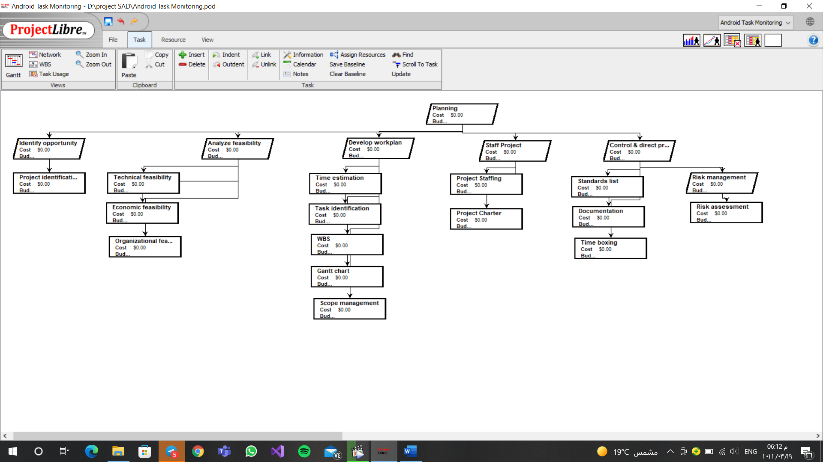

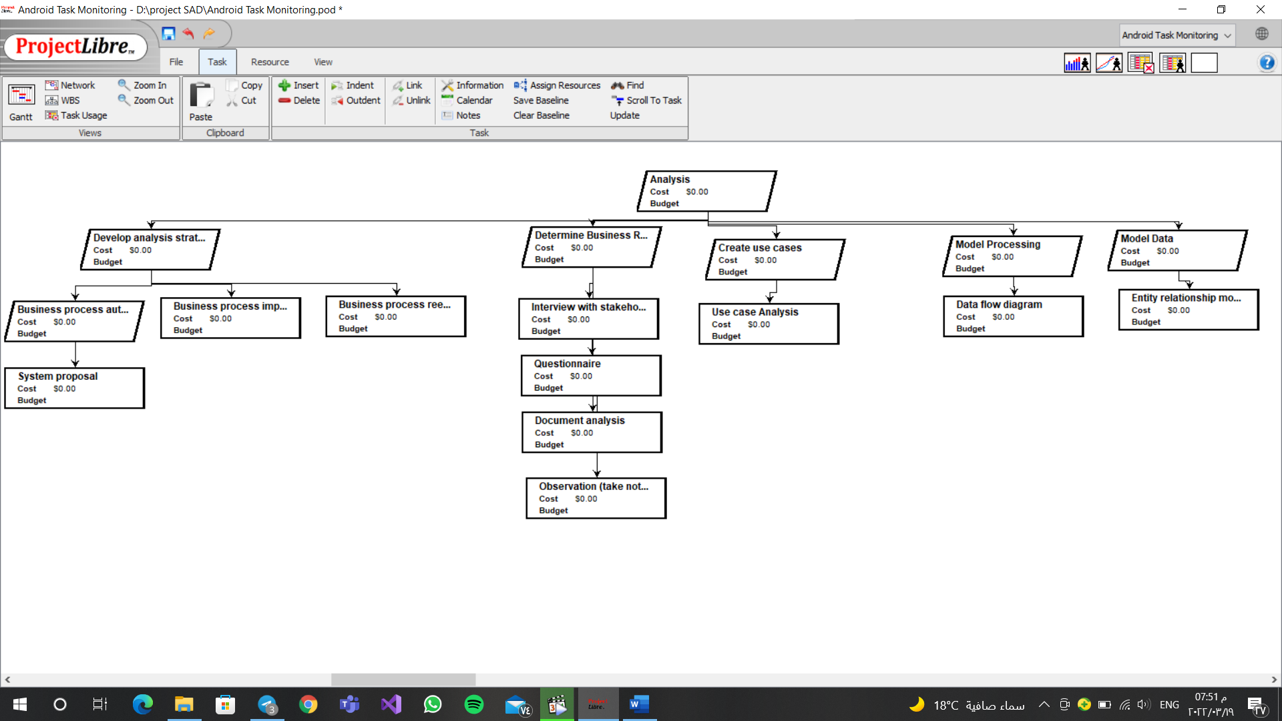

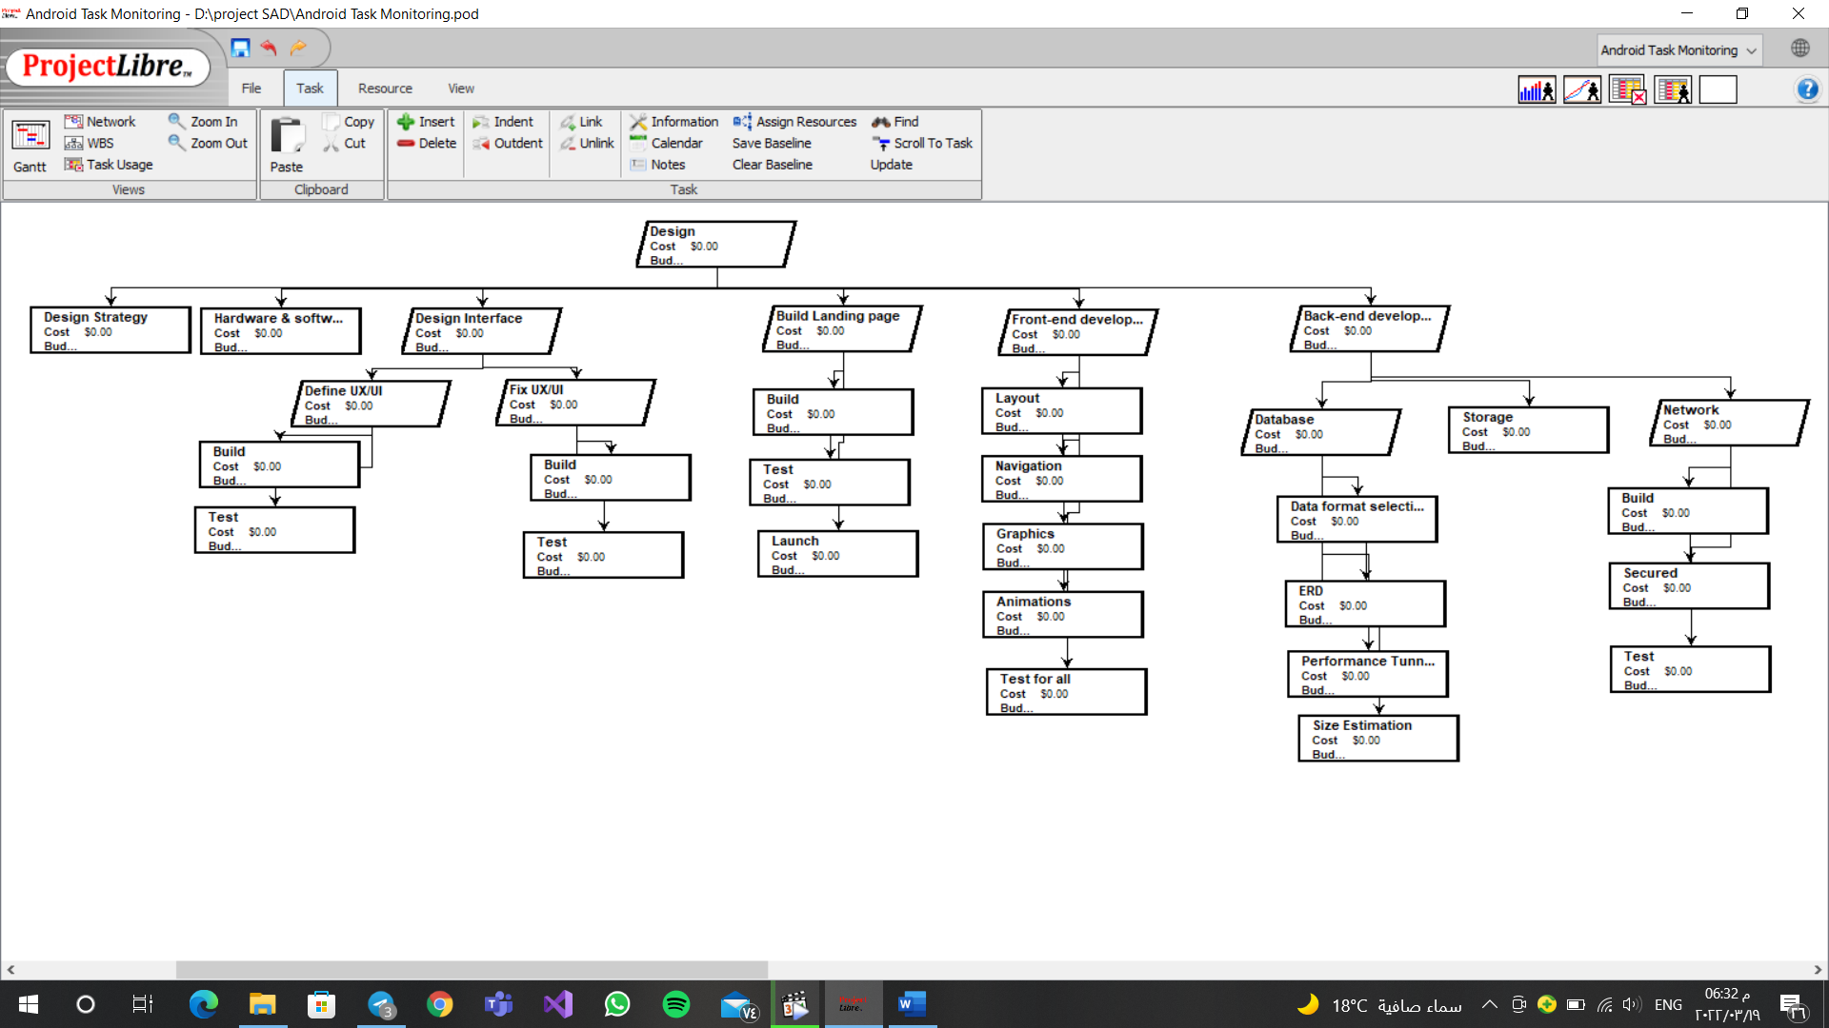

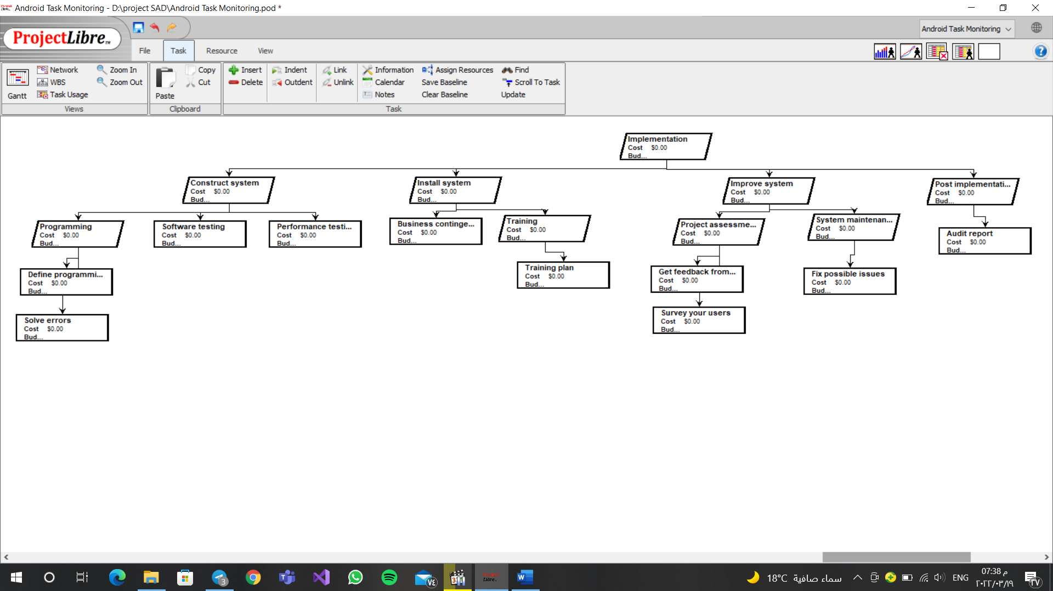

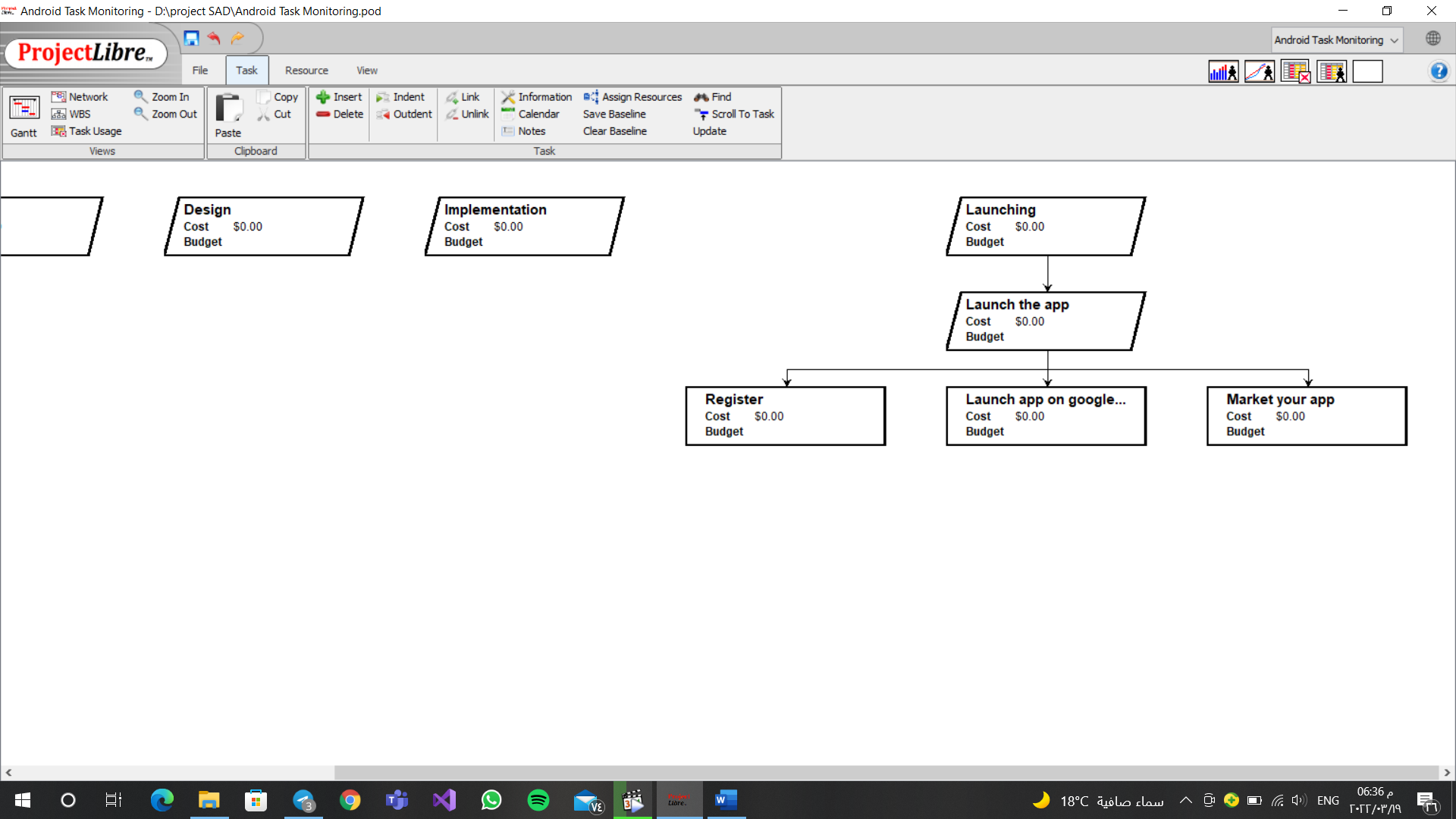

|  |  |  |  |  |  |  |  |  |  |  |
| --- | --- | --- | --- | --- | --- | --- | --- | --- | --- | --- |
| Task id | Task name | Assigned to | Estimated | | | Actual | | | Dependency | Status |
| Duration (days) | Start date | Finish date | Start date | Finish date | Duration variance |
| 1 | **Planning** |  | 60 | 1/1 | 3/3 |  |  |  |  | Open |
| 1.1 | Identify opportunity | Maria | 3 | 1/1 | 4/1 | 1/1 | 4/1 | 0 |  | Complete |
| 1.1.1 | Project identification | Maria | 3 | 1/1 | 4/1 | 1/1 | 4/1 | 0 |  | Complete |
| 1.2 | Analyze feasibility |  | 5 | 5/1 | 9/1 | 5/1 | 9/1 | 0 | 1.1 | Complete |
| 1.2.1 | Technical feasibility | Mary Clara | 1 | 5/1 | 6/1 | 5/1 | 6/1 | 0 | 1.1.1 | Complete |
| 1.2.2 | Economic feasibility | Marian Kirollos | 3 | 6/1 | 9/1 | 6/1 | 9/1 | 0 |  | Complete |
| 1.2.3 | Organizational feasibility | Mary-Clara | 1 | 5/1 | 6/1 | 5/1 | 6/1 | 0 |  | Complete |
| 1.3 | Develop workplan |  | 15 | 10/1 | 25/1 | 10/1 | 25/1 | 0 | 1.2 / 1.1 | Complete |
| 1.3.1 | Time estimation | Maria | 5 | 10/1 | 15/1 | 10/1 | 15/1 | 0 | 1.2.1 | Complete |
| 1.3.2 | Task identification | Clara | 2 | 15/1 | 17/1 | 15/1 | 17/1 | 0 |  | Complete |
| 1.3.3 | WBS | Maria  Clara  Mary  Marian | 3 | 17/1 | 20/1 | 17/1 | 20/1 | 0 | 1.3.2 | Complete |
| 1.3.4 | Gantt chart | Maria | 1 | 20/1 | 21/1 | 20/1 | 21/1 | 0 | 1.3.1/1.3.3 | Complete |
| 1.3.5 | Scope management | Kirollos | 4 | 21/1 | 25/1 | 21/1 | 25/1 | 0 | 1.1 / 1.2 / 1.3.1 | Complete |
| 1.4 | Staff project |  | 15 | 25/1 | 9/2 |  |  |  |  | Open |
| 1.4.1 | Project staffing(Staffing plan) | Clara | 10 | 25/1 | 4/2 |  |  |  | 1.3.2 / 1.3.4 | Open |
| 1.4.2 | Project charter | Marian | 5 | 4/2 | 9/2 |  |  |  | 1.3.5 / 1.3.4 | Open |
| 1.5 | Control & direct project |  | 22 | 9/2 | 3/3 |  |  |  |  | Open |
| 1.5.1 | Standards list | Mary | 7 | 9/2 | 16/2 |  |  |  | 1.3.5 | Open |
| 1.5.2 | Documentation | Kirollos | 5 | 16/2 | 21/2 |  |  |  | 1.1 / 1.2 /1.3/ 1.4 | Open |
| 1.5.3 | Time boxing | Maria | 4 | 21/2 | 25/2 |  |  |  | 1.3.1 | Open |
| 1.5.4 | Risk management | Marian | 6 | 25/2 | 3/3 |  |  |  |  | Open |
| 1.5.4.1 | Risk assessment | Marian | 6 | 25/2 | 3/3 |  |  |  | 1.4.2 | Open |
| 2 | **Analysis** |  | 120 | 4/3 | 2/7 |  |  |  | 1 | Open |
| 2.1 | Develop analysis strategy |  | 45 | 4/3 | 18/4 |  |  |  |  | Open |
| 2.1.1 | Business process automation | Maria | 10 | 4/3 | 14/3 |  |  |  |  | Open |
| 2.1.1.1 | System proposal | Maria | 10 | 4/3 | 14/3 |  |  |  |  | Open |
| 2.1.2 | Business process improvement | Mary | 20 | 14/3 | 3/4 |  |  |  |  | Open |
| 2.1.3 | Business process reengineering | Marian | 15 | 3/4 | 18/4 |  |  |  |  | Open |
| 2.2 | Determine Business Requirements |  | 40 | 18/4 | 28/5 |  |  |  | 2.1 | Open |
| 2.2.1 | Interview with stakeholders | Clara | 10 | 18/4 | 28/4 |  |  |  |  | Open |
| 2.2.2 | Questionnaire | Kirollos | 10 | 28/4 | 8/5 |  |  |  | 2.2.1 | Open |
| 2.2.3 | Document analysis | Maria | 10 | 8/5 | 18/5 |  |  |  | 2.2.1/2.2.2 | Open |
| 2.2.4 | Observation (take notes) | Marian | 10 | 18/5 | 28/5 |  |  |  | 2.2.3 | Open |
| 2.3 | Create use cases | Mary  Kirollos | 10 | 28/5 | 7/6 |  |  |  |  | Open |
| 2.3.1 | Use case Analysis | Mary  Kirillos | 10 | 28/5 | 7/6 |  |  |  | 2.1/2.2 | Open |
| 2.4 | Model Processing | Marian | 15 | 7/6 | 22/6 |  |  |  |  | Open |
| 2.4.1 | Data flow diagram | Marian | 15 | 7/6 | 22/6 |  |  |  | 2.1/2.2/2.3 | Open |
| 2.5 | Model Data | Clara | 10 | 22/6 | 2/7 |  |  |  |  | Open |
| 2.5.1 | Entity relationship modeling | Clara | 10 | 22/6 | 2/7 |  |  |  | 2.4 | Open |
| 3 | **Design** |  | 90 | 2/7 | 2/10 |  |  |  | 1 /2 | Open |
| 3.1 | Design Strategy | Clara  Mary  Kirollos | 10 | 2/7 | 12/7 |  |  |  |  | Open |
| 3.2 | Hardware & software selection | Maria  Marian | 5 | 12/7 | 17/7 |  |  |  | 3.1 | Open |
| 3.3 | Design Interface |  | 7 | 17/7 | 24/7 |  |  |  | 3.1 / 3.2 | Open |
| 3.3.1 | Define UX/UI |  | 4 | 17/7 | 21/7 |  |  |  |  | Open |
| 3.3.1.1 | Build | Marian | 3 | 17/7 | 20/7 |  |  |  | 3.3.1/ 3.1 | Open |
| 3.3.1.2 | Test | Kirollos | 1 | 20/7 | 21/7 |  |  |  | 3.3.1.1 | Open |
| 3.3.2 | Fix UX/UI |  | 3 | 21/7 | 24/7 |  |  |  | 3.3.1/3.1 | Open |
| 3.3.2.1 | Build | Maria | 2 | 21/7 | 23/7 |  |  |  | 3.3.2 | Open |
| 3.3.2.2 | Test | Clara | 1 | 23/7 | 24/7 |  |  |  | 3.3.2.1 | Open |
| 3.4 | Build Landing page |  | 8 | 24/7 | 1/8 |  |  |  | 3.1 | Open |
| 3.4.1 | Build | Mary | 4 | 24/7 | 28/7 |  |  |  |  | Open |
| 3.4.2 | Test | Maria | 2 | 28/7 | 30/7 |  |  |  | 3.4.1 | Open |
| 3.4.3 | Launch | Clara | 2 | 30/7 | 1/8 |  |  |  | 3.4.2 | Open |
| 3.5 | Front-end development |  | 30 | 1/8 | 31/8 |  |  |  | 3.1 | Open |
| 3.5.1 | Layout | Clara | 6 | 1/8 | 7/8 |  |  |  |  | Open |
| 3.5.2 | Navigation | Mary | 6 | 7/8 | 13/8 |  |  |  |  | Open |
| 3.5.3 | Graphics | Marian | 6 | 13/8 | 19/8 |  |  |  |  | Open |
| 3.5.4 | Animations | Maria | 6 | 19/8 | 25/8 |  |  |  |  | Open |
| 3.5.5 | Test for all | Kirollos | 6 | 25/8 | 31/8 |  |  |  | 3.5.1/3.5.2/3.5.3/  3.5.4 | Open |
| 3.6 | Back-end development |  | 30 | 31/8 | 1/10 |  |  |  | 3.1 | Open |
| 3.6.1 | Database |  | 20 | 31/8 | 20/9 |  |  |  |  | Open |
| 3.6.1.1 | Data format selection | Maria | 4 | 31/8 | 4/9 |  |  |  |  | Open |
| 3.6.1.2 | ERD | Clara | 9 | 4/9 | 13/9 |  |  |  | 3.6.1.1 | Open |
| 3.6.1.3 | Performance Tunning | Kirollos | 4 | 13/9 | 17/9 |  |  |  | 3.6.1.1/3.6.1.2 | Open |
| 3.6.1.4 | Size Estimation | Mary | 3 | 17/9 | 20/9 |  |  |  | 3.6.1.1 | Open |
| 3.6.2 | Storage | Marian | 4 | 20/9 | 24/9 |  |  |  | 3.1/3.6.1 | Open |
| 3.6.3 | Network |  | 6 | 24/9 | 30/9 |  |  |  | 3.1 | Open |
| 3.6.3.1 | Build | Marian | 3 | 24/9 | 27/9 |  |  |  |  | Open |
| 3.6.3.2 | Secured | Clara | 2 | 27/9 | 29/9 |  |  |  | 3.6.3.1 | Open |
| 3.6.3.3 | Test | Mary | 1 | 29/9 | 30/9 |  |  |  | 3.6.3.2 | Open |
| 4 | **Implementation** |  | 60 | 30/9 | 29/11 |  |  |  | 1/2/3 | Open |
| 4.1 | Construct system |  | 20 | 30/9 | 20/10 |  |  |  |  | Open |
| 4.1.1 | Programming |  | 10 | 30/9 | 10/10 |  |  |  |  | Open |
| 4.1.1.1 | Define programming languages | Marian | 5 | 30/9 | 5/10 |  |  |  | 3.2 | Open |
| 4.1.1.2 | Solve errors | Maria | 5 | 5/10 | 10/10 |  |  |  |  | Open |
| 4.1.2 | Software testing | Kirollos | 5 | 10/10 | 15/10 |  |  |  | 4.1.1 | Open |
| 4.1.3 | Performance testing | Mary | 5 | 15/10 | 20/10 |  |  |  | 4.1.1/4.1.2 | Open |
| 4.2 | Install system |  | 15 | 20/10 | 4/11 |  |  |  | 4.1 | Open |
| 4.2.1 | Business contingency plan | Clara | 5 | 20/10 | 25/10 |  |  |  |  | Open |
| 4.2.2 | Training | Kirollos | 10 | 25/10 | 4/11 |  |  |  |  | Open |
| 4.2.2.1 | Training plan | Kirollos | 10 | 25/10 | 4/11 |  |  |  | 4.2.1 | Open |
| 4.3 | Improve system |  | 20 | 4/11 | 24/11 |  |  |  | 4.1/4.2 | Open |
| 4.3.1 | Project assessment |  | 10 | 4/11 | 14/11 |  |  |  |  | Open |
| 4.3.1.1 | Get feedback from user | Marian | 5 | 4/11 | 9/11 |  |  |  |  | Open |
| 4.3.1.2 | Survey your users | Mary | 5 | 9/11 | 14/11 |  |  |  |  | Open |
| 4.3.2 | System maintenance | Maria | 10 | 14/11 | 24/11 |  |  |  |  | Open |
| 4.3.2.1 | Fix possible issues | Maria | 10 | 14/11 | 24/11 |  |  |  | 4.3.1 | Open |
| 4.4 | Post implementation | Clara | 5 | 24/11 | 29/11 |  |  |  |  | Open |
| 4.4.1 | Audit report | Clara | 5 | 24/11 | 29/11 |  |  |  | 4.1/4.2/4.3 | Open |
| 5 | **Launching** |  | 30 | 29/11 | 29/12 |  |  |  | 1/2/3/4 | Open |
| 5.1 | Launch the app |  | 30 | 29/11 | 29/12 |  |  |  |  | Open |
| 5.1.1 | Register |  | 10 | 29/11 | 9/12 |  |  |  |  | Open |
| 5.1.2 | Launch app on google play | Kerollos | 5 | 9/12 | 14/12 |  |  |  |  | Open |
| 5.1.3 | Market your app | Clara  Mary  Marian  Maria | 15 | 14/12 | 29/12 |  |  |  |  | Open |